**PetCare+ –>Specialized Veterinary Treatment Slot Booking System**

**PHASE 8**

**1. Data Import Wizard**

Why it is Needed: To quickly load initial data like Pets, Owners, Slots, and Doctors into Salesforce.  
Use / How it helps:

* Helps you create multiple records in bulk without manual entry.
* Use Salesforce’s Data Import Wizard to upload CSV/Excel files for Pets__c, Owners__c, and Slot__c.

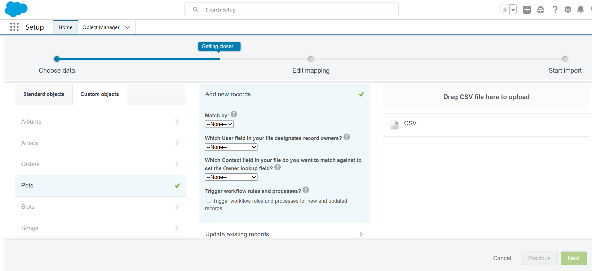

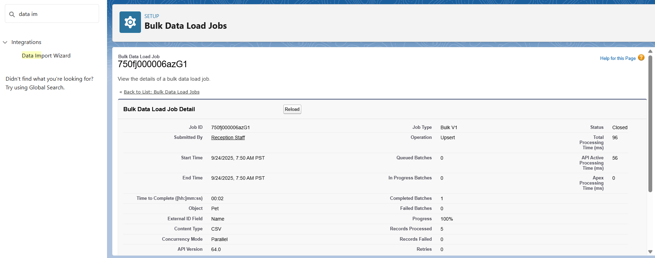

**2. Duplicate Rules**

Why it is Needed: To prevent creation of duplicate Pet__c or Owner records.  
Use / How it helps:

* Ensures data integrity by blocking duplicate phone numbers, emails, or other key fields.
* Helps maintain clean and reliable records for accurate slot booking and reporting.

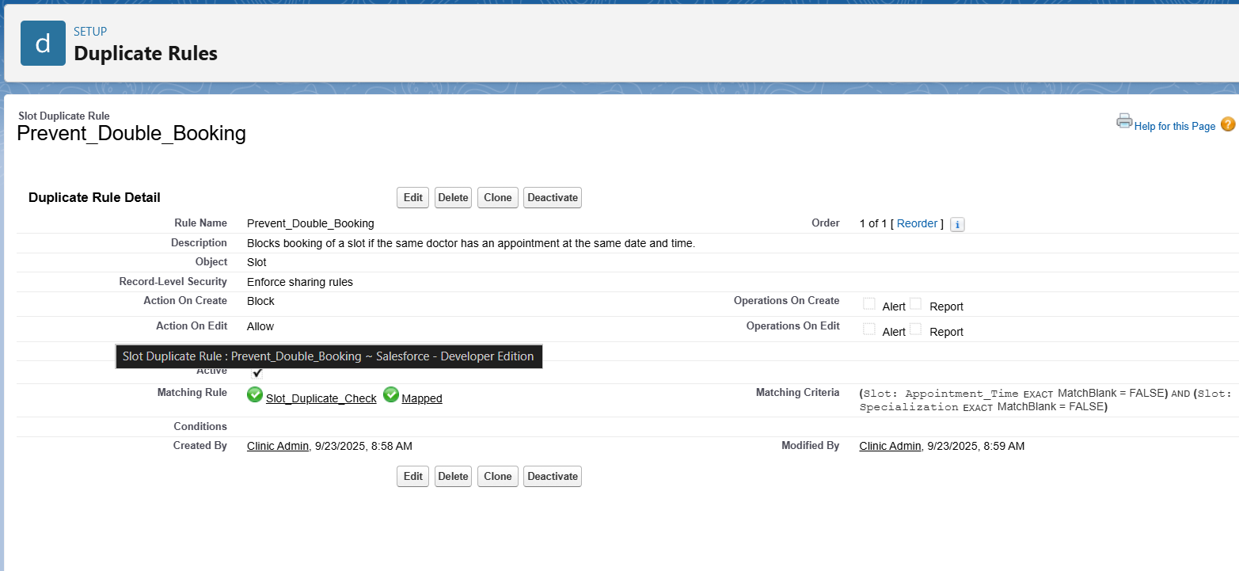

**3. Data Export & Backup**

Why it is Needed: To back up critical data like appointments, pets, and treatments.  
Use / How it helps:

* Helps you demonstrate best practice of regularly saving Salesforce data.
* Use Salesforce’s Data Export tool to download CSVs weekly or monthly.

